**F. Y. M. Tech (ECE)**

**Trimester: I Subject: Embedded System Design** (**ECE5015A)**

**Name:Anupama Prasad Class: F.Y.M.Tech**

**Roll No: 1032212131 Batch: 2021-2022**

**Assignment No: 08**

**Name of the Assignment**: **Writing device driver for simple application with embedded Linux**

|  |
| --- |
| **Marks** |
|  |
|  |

**Teacher’s Signature with date**

**Performed on: 27/10/2021**

**Submitted on: 31/10/2021**

**Aim: Writing device driver for simple application with embedded Linux Objective: To write simple “Hello World” program.**

**Procedure:**

* Open the putty utility and login in the central computing systems login : edutech

Password: edutech

* Start the Hello world session in linux central computing systems.

$ cd /home/edutech/arm9

Make new folder and file using mkdir newfolder cd filename.c

write down the hello world program and save the program file as hello.c

* Using the Editor modify the hello.c program

$ vi hello.c

1. Save the program using Esc + :: + w + q

* Build /compile the program.

$ make clean (to remove old files)

$ make (it will compile the device driver program)

* Copy it to the /tftpboot

$ cp hello.ko /tftpboot

Copy hello.ko to target board and change its permission [root@EDUTECH] cd /home/driver/

[root@EDUTECH] tftp -g -r hello.ko 172.20.51.148 (IP address of server) 24 [root@EDUTECH] chmod 777 hello.ko

insmod hello.ko

**Program:**

/* Example Minimal Character Device Driver */ #include <linux/module.h>

static int inithello_init(void)

{

printk(KERN_INFO “Hello Example Init\n”); return 0;

}

static void exit hello_exit(void)

{

printk(“Hello Example Exit\n”);

}

module_init(hello_init); module_exit(hello_exit);

MODULE_AUTHOR(“Chris Hallinan”);

MODULE_DESCRIPTION(“Hello World Example”); MODULE_LICENSE(“GPL”);

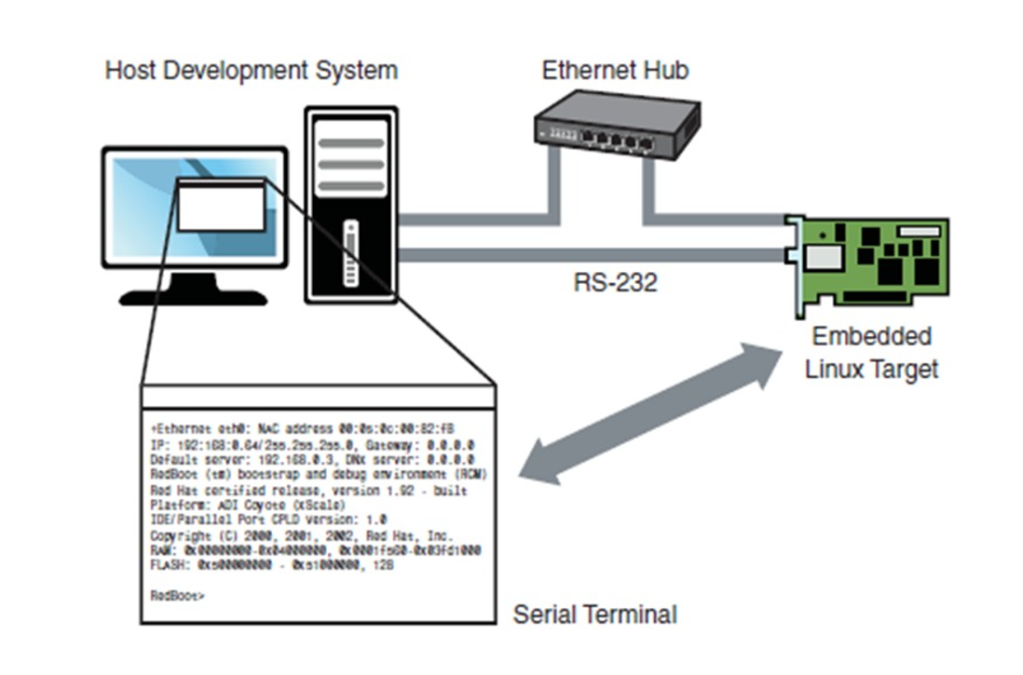

**Conclusion:**

A device driver to display “Hello World” was written and executed using make-file. When the device driver was inserted to target device, output was printed on the terminal as “Hello! Driver is inserted” and after remaining the driver the driver, it printed “Bye! Driver is removed”.